Project Title

E-banking website of Muslim Commercial Bank Ltd

Table of Content
- Business case study / feasibility study
  - Introduction to organization
  - Objectives of organization
  - Mission statement
  - Functional Areas
  - Problems in organization
  - Reason for undertaking the project
  - Option available
  - Recommendation
  - Cost
  - Benefits
  - Cost/benefits analysis
  - Technical feasibility
  - Economic feasibility
  - Operational feasibility
  - Risk analysis & management
  - Conclusion
- IT Analysis
  - Current it state
  - IT Objective
  - IT Problems analysis
  - IT Option
- Investigation of current system
  - Problem Definition
  - Problem with current system
  - Recommendation
- Proposed system
  - Detailed Description
  - System Analysis
    - System outline
    - Context diagram
    - High-level data flow diagram
    - Low level data flow diagram
    - Normalize ERD
  - System Design
    - Database Design
    - Table Design
    - Screen / Report design layout
- Appendices
  - Activity network analysis
  - Supplier’s specifications
  - Stakeholders’ communication
  - Coding
  - Sitemap

Business case study / feasibility study

Introduction organization
MCB was started its life in Calcutta on July 9, 1947. In 1948. In 1956, it transferred as registered office to Karachi. Then it works hard to become a successful bank. In 1974, the govt. of Pakistan nationalized it. In 1991, MCB became Pakistan’s 1st privatized bank.After the partition of the INDO-PAK subcontinent the bank moved to Dhaka from where it commenced business in August 1948.
The govt of Pakistan transferred the management of the bank to national group by selling 26% shares of bank. With a view to broaden equality holding the govt. sold 25% of the paid up capital to the general public. MCB today a presence in the three countries around the global namely Siri Lanka, Bangladesh, and Behreen. There are two Branches in Bangladesh and three in Siri Lanka and bahreen.
The international division provides one of the fastest means of remittance from the Middle East and other countries and also has Pakistani rupees and Dollar drawing arrangements. Today MCB is a major financial institution in Pakistan. Now MCB is deciding to introduce new technology and improve its services it is feasible & beneficial for him. This study defines either it is beneficial to undertake the project or not.

Objectives of organization
- To become a leading bank in Pakistan.
- To have an international presence.
- To provide quality service toward customers.
- To provide innovative technology with modern & progressive organization

Mission statement
To become the preferred provider of quality financial services in the country with profitability and responsibility and to be the best place to work.

Functional Areas

Bank Branches (as sales Department)
Their main functions are following
- New account opening, new customers opens their account in bank branches
- Cash deposit customer’s deposits money in their accounts through bank branches
- Withdraw money customers withdraw from bank branches
- Utility bills payments bank branches accept utility bills payments from customers
- Loan services loan is provided to customers through bank branches

Following documents are used at sales department
- New account form
- ID card copy
- Cash deposit slip
- Cash deposit slip
- Cash withdraw cheque
- Bank statement
- Chequebooks
- Cash deposit slip

Marketing Department
Their main functions are following
- Introduce New schemes
- Advertise in the media
- Make a market research
- Make a market campaign

Following documents are used at marketing department
- Market research
- Order for new advertisement
- Cost reports

Human Resource department
Their main functions are following
- Pay roll of employees
- Staff recruitment
- Staff records maintenances

Following documents are used
- Documents
Application of candidate
- Employees attendance sheet
- Letter to successful candidate
- Letter to successful candidate
- Pay slip
- Report to administration

IT Department
Their main functions are following
- Purchase of hardware\software etc
- Provide maintenance service of hardware software to other departments
- Development of software
- Maintenance of network

Following documents are used
- Purchase request Form
- Problem letter by departments
- Receives tele-banking services application from through bank branches

Administrator Department
Their main functions are following
- Policymaking
- Monitor the others
- Make plan

Following documents are used
- Reports from different department
- Rules policy detail
- Warning letter to other department

Problems in organization

Customers’ services
- Person has to go bank or use phone call to bank for checking their account balance & bank statements. But with phone call only one person can be handled.
- People transfers money to other accounts. It takes time to transfer money.
- People pay utility bills. It is also time-consuming procedure for bill payments.

Bank services
- More use of paper-based work.
- Non-availability of service i.e. bank timing or non-functional ATMs.

Reason for undertaking the project
- Online service will be essential in the future.
- It is new technology. It will improve the image of MCB.
- We will get the maximum customers market.
- Scope of bank will be worldwide.
- With online services, customer will be increased.

Option available
- Increase the people to solve the non-availability of service
- Reduce paper work by proper allotment of papers.
- Computerized the whole system. So the whole system is integrated.
- Make an e-banking web site that allows customers online queries and transactions

Recommendation
It is recommended that the e-banking web site is most appropriate option to suit the bank’s requirements.

Cost
Cost (in lakh)
No. | Item | Cost
1 | Development cost | 8.5
1.1 | Analysis | 1.8
1.2 | Design | 1.8
1.3 | Development | 2.4
1.4 | Testing | 1.2
1.5 | Implementation | 1.3
2 | Hardware cost | 1.6
2.1 | Server | 0.8
2.2 | Backup server | 0.8
3 | Software cost | 1.0
3.1 | Operating system | 0.5
3.2 | Programming language | 1.0
3.3 | Database | 1.0
4 | Running cost (yearly) | 1.0
4.1 | Electricity bill | 0.74
4.2 | Other | 0.16

Benefits
- In clerical work, benefit is 1.5 lakh
- New customer will increase 20%. So approximately 1.5 lakh will earn in a year
- Online transaction will be 30%. We will charge on that so that will be approximately 2.9 lakh.
- Papers cost previously was 5 lakh. Now it will be 2.5 lakh due to online form filling and document transferring

Cost/benefits analysis

Cost benefit analysis diagram
Costs | Yr0 | Yr1 | Yr2 | Yr3 | Yr4 | Yr5 | Total
Analysis | 1.8 |  |  |  |  |  | 1.8
Design | 1.8 |  |  |  |  |  | 1.8
Coding | 2.4 |  |  |  |  |  | 2.4
Testing | 1.2 |  |  |  |  |  | 1.2
Installing | 1.3 |  |  |  |  |  | 1.3
Hardware | 1.6 |  |  |  |  |  | 1.6
Other | 2.5 |  |  |  |  |  | 2.5
Running | 1 | 1 | 1 | 1 | 1 | 1 | 6
Total | 13.6 | 1 | 1 | 1 | 1 | 1 | 18.6
Savings
Clerical | 0 | 1.5 | 1.5 | 1.5 | 1.5 | 1.5 | 7.5
Paper | 0 | 2.5 | 2.5 | 2.5 | 2.5 | 2.5 | 12.5
Other | 0 | 2.3 | 2.3 | 2.3 | 2.3 | 2.3 | 11.5
Benefits
Image | 0 | 1.6 | 1.6 | 1.6 | 1.6 | 1.6 | 8
Transaction | 0 | 2.9 | 2.9 | 2.9 | 2.9 | 2.9 | 14.5
Other | 0 | 1.3 | 1.3 | 1.3 | 1.3 | 1.3 | 6.5
Total | 0 | 12.1 | 12.1 | 12.1 | 12.1 | 12.1 | 60.5
Net benefit | -13.6 | 11.1 | 11.1 | 11.1 | 11.1 | 11.1 | 41.9
Discount factor (6%) | 1.0 | 0.94 | 0.89 | 0.84 | 0.79 | 0.75 | -
Discounted net benefit | -13.6 | 10.4 | 9.9 | 9.3 | 8.8 | 8.3 | 33.1
Cash flow | -13.6 | -2.5 | 8.6 | 19.7 | 30.8 | 41.9 | 84.9
Discounted cash flow | -13.6 | -3.2 | 6.7 | 16 | 24.8 | 33.1 | 63.8

Description of cost benefit analysis
- Total developing cost with running cost is 18.6 lakh.
- Total new benefit is 41.9 lakh but due to timer factor we calculate the discounted net benefit
- After five years cash flow would be 84.9 lakh. With respect to discount factor of 6%, discounted cash flow would be 48.8 lakh.

Technical feasibility
- E-banking web site is a possible solution. We will need server and software IIS to support ASP.
- There is not a complete set of hardware and software exists that supports the proposed system
- We need some extra hardware e.g. web server and software e.g. IIS to support ASP
- All the branches of MCB have not been online yet. To fully implement the e-banking system, it is better to online all other branches that are not online yet.

Economic feasibility
- It can be easily feasible for MCB to undertake the project.
- The total cost is 18.6 lakh and total benefits are 60 lakh so it is a good profit oriented project.
- Less employee will be required so this project will decrease the employee payment cost

Operation feasibility
- Some people are available in MCB who will operate the new project but some training will be required for others.
- New system will decrease the amount of equipment usage e.g. data will be stored directly on the server not going through different departments to reach a proper place.

Risk analysis & management

Risk analysis
Risk# | Risk identification | Risk estimation | Risk evaluation
1 | Server failure | Online system will stop | Not acceptable so make a backup server
2 | Data loss | Customer will loss | Not acceptable so make regular backup of data
3 | Hacking | Unauthorized money usage | Not acceptable so use powerful encryption data transmission
4 | Main developer leaves | Not on time project delivery | Not acceptable so maintain a link with other developer or make a proper analysis and design documentation.
5 | Load on server | Service not available error | Not acceptable so reduce response time to a acceptable level.

Risk management
Risk # | Planning | Re-sourcing | Monitoring | Controlling
1 | Select/use the most reliable server | Use backup server | Check the server is in functional stage | Ensure that switch to backup server is accurate and possible
2 | Take a backup of important data | User backup hard disk or RAID devices | Check data is storing on back devices | Recovery of data is easy and valid if needed
3 | User good encryption | User a software encryption or a hardware device for encryption | Check any unusual activity happening | Ensure that the source location of each person is recorded
4 | Hire the versatile developing team | Make a extra link with other developers | Guess which developer is preparing to leave | Ensure that developer will be available if needed
5 | User priority and response-time system | Special operating system and software needed | Check the time for load on server | Ensure that the priorities are correct and response time is acceptable.

Conclusion
- MCB should switch to online business as more organizations are doing it
- Customers are also demanding the online services so it is good as early as possible.
- It is concluded that e-banking website is required to enable MCB on competitive edges

IT Analysis

Current it state

Fax
They are using the two servers for the fax purpose. One is installed on the main branch and another is Islamabad. The name for the fax server is IBM fax server for the purpose of faxing

Server
The many servers are two one is handling totally the ATMs machines and other is used for the purpose of storing the data and sending the data.

Printer
they are using the two types of printers. One is which is used for the only the IT department and with dot matrix and other is laser.

Leased line
for connecting the different branches they used the leased line,

Encryption
Encryption machine is used for the purpose of encryption of data.
Branch Network the most of the MCB branches are linked with the computers through the Ethernet

Modem
They are using the modem to connect the different computers with the web.

Routers
They are using two types of routers, one the Motorola and other is Cisco Routers.

VPN
VPN (virtual private network) is used for the internal communication with those branches that are not on line

ATMs
These are used to cash money.

IT Objective
- We want to improve the services through the online system. We want to give the services to customer through the online systems. Through this way we can improve our customer. Customer can access the services through the net from anywhere.
- Customer can easily transfer the money and bill payments from any where through the online.

IT Problems analysis
- People checks their account balance at the bank, ATMs or through the phone call, But there is a problem if the bank timing is off, ATM is not available in your area or only one person can check the balance.
- For the bill payment people go the banks and then pay the bill to the bank. People are facing lot of problems because they’re so many people in order to pay the bill in the bank. Because they’re only few employees in order to collect the bill. That’s why we can offer the people to pay the through online system.
- Transfer the money from one bank account to another bank there is slow process.
- Processing of manual work is too much slow i.e. new customer account opening.
- Same employee in the bank does multiple jobs.
- Information is not stored at the central place.

IT Option
- Option 1
  - Purchase web space on server
  - Hardware: Pentium 4
  - Operating system: Windows 2000 Advance Server
  - Software: Internet Information Server (IIS)
  - Development tools: Visual Basic/Active Server Pages
  - Database: SQL Server/Access
- Option 2
  - Create your own web-server
  - Operating system: Linux
  - Development tools: PHP
  - Database: My SQL
- Option 3
  - Hardware: Pentium 4
  - Operating system: Windows NT
  - Development tools: Active Server Pages
  - Database: Oracle

Investigation of current system

Problem Definition
- People can check their account balance only from the bank not elsewhere. People face a lot of problems in order to check the balance.
- If and account holder want to get his account bank statement he comes at bank first then he get the bank statement. in this procedure he waste a lot of time and resources.
- Transfer of money from on account to another is also a big problem because every accountholder need to go at bank tell to bank employee he want to transfer the money to another account. For the completion of this procedure a lot of time is wasted.
- The employees of the bank doing the multiple works at the same time, that way of working of employees apply a bad effect on the customers those are come for doing some transaction.
- People was faced a lot of problems in bill payment because many of people come at the same for the payment of the bill only person is doing the work of bill collection this also a big problem.
- Different department need some information from other departments, tese departments have get the information at time and also not in a proper form. So this department are linked with each other in a good way.
- People have account in a branch he can do the transaction through this branch not from anywhere else.
- People were facing a lot of problems in order to check the transaction detail of their accounts.

Problem with current system
- They are using the command line interface and using the Linux and Unix both are not user-friendly environment.
- Servers required special configuration for the different operating system.
- Using two servers for the different purpose.
- The people have check the balance from any where they need to go the bank and then they can check the balance other wise they have not information about the balance
- The data is not stored at one place.
- Departments have face a lot of problems in order to get information from other departments.
- Branches are not interconnected with each other.
- Branches face lot problems in order to send the information to the main head office.
- Not easy to send information to the other companies like the ptcl and wapda etc, branches faces the problems in order to send the information to theses companies.
- A lot of resources used in order to save the information.
- The employees are too much in the some branches.
- People have not the option to do the transactions online.
- They need to go at bank if they need the bank statement
- Currently they are some IT equipment those are not enough the online system.

Recommendation
- Windows 2000 advance: server because it is easier to use than the Unix although Unix are more powerful but it is difficult to work on.
- SQL server supports windows 2000 and it is greater than MS-Access.
- Internet information server (IIS) is required for the active server pages (ASP).
- Pentium 4 it betters in speed and performance

Proposed system

Detailed Description
- E-banking will improves the images of the Muslim commercial bank in market.
- E banking provides the services to the customer in better way and also anywhere in the country.
- Muslim commercial bank easily deals with the other bank through the new system.
- Muslim commercial bank got more profit the new system because more and more people open their accounts and do the transaction through online system so the bank got some money on every transaction.
- The customer can access the bank not only with the country they can easily access from out side the country.
- Customer’s services will improve the total customer of Muslim commercial bank.
- According to the mission of MCB implement lying e banking, MCB will be the best place for business work.

System analysis

System Outline
Inputs
New Customer Information
Updated Customer Information
Bill Payment
Online Purchase
Money Transfer

Processes
Creation of new customer record
Maintenance of customer record
Creation of bill

Transfer of Money
Validate new customer
Calculation of account balance
Creation of Bank Statement

Files/Tables
Customer
Account
Deposit
Withdrawal
Transaction
Billing Companies
Shops

Output
Account Balance
Bank Statement
List of Referred person
List of Account
Utility bills payment
Online purchases detail

Context diagram
Request for BS
Customers Payments
A/c balance
New schemes
Request for operations
Bill payment
Online shop
More customers
Account information
Account detail
Request for summaries
Balance of account
Report of account
Deposited transaction
Transaction detail
New account detail
Balance
Customer
Administrator
Customer
Marketing
ATMs
Request for new aaccount
MCB

Online

Customers

Services
Customer
Person
Customer
Customer
Bank Branch
Person
Customer
Customer
Branches
Administrator
Marketing dp
ATMs
Company
Shop
Person
Refer to other person
Deposit

High-level data flow diagram
Customer
New Customer Information
Filled Form
Form Send
New Account Request
Conformation
Person
1 Web Site

New Customer
Creation
Customer
D1

Transaction
Transaction
New Detail
Edit Info
Customer
2 Customer

Maintenance of Customer Record
Customer
3 Web Site

Creation of transaction
D2
Transaction

Refer to detail information
Refer to detail information
Refer to detail
Customer
4 Web Site

Creation of reference to other person
D2

Transitioned money
Transaction
Account Information
Customer Information
Account
Account Balance
Account Balance
Customer
Deposit
Withdraw
Account Balance Request
Customer
5 Account

Calculation of
Account Balance
D4
D7
D6
D5
D8
Customer
Shop
Deposit Money
Withdraw money
Shop

Withdraw
Transaction
Deposit
D

Creation of bank statement
6 Web site
Customer
D
D
Customer

Low level data flow diagram
Valid Person
New Customer
Confirmation
Refer to detail
Information
Refer to
Customer
Customer
Customer

Validate new customer
D
Customer
Customer

Creation of new
Customer
D

Customer
New information
New information
New information
Customer
Web Site

Receive latest information

Customer
Update customer
D

Account
Customer
3.1 Web Site
Validate the Account balance
3.2 Account
Update customer
Information
D

Normalize ERD

Shop
Billing Company
Account Holder
User
User Type
Account
Account type
Refer to
Deposit
Width draw
Branch
Transaction
Transaction type
Billing

System design

Database design
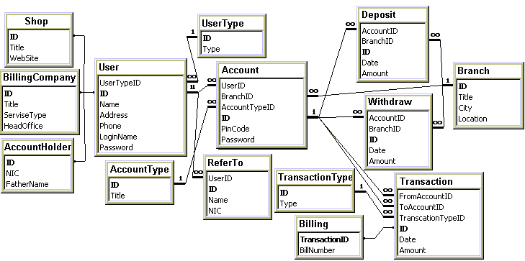

Table design

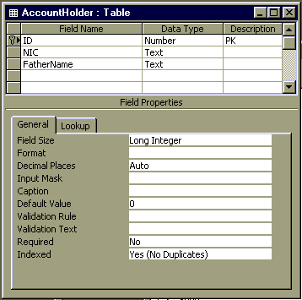 | 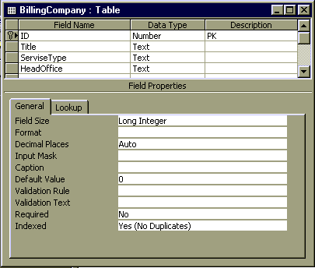
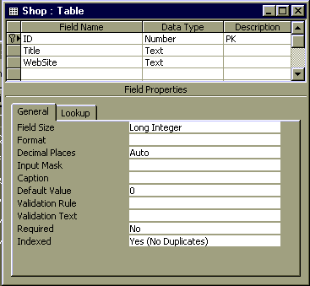 | 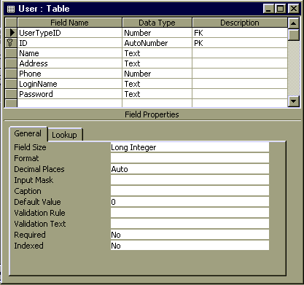
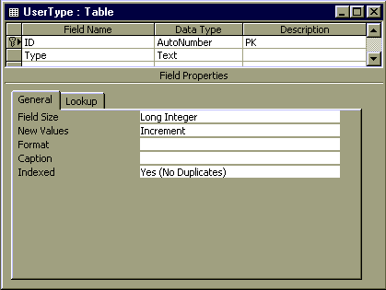 | 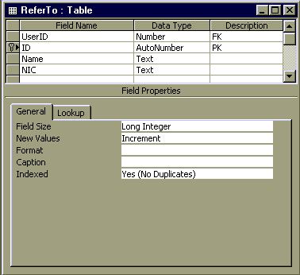
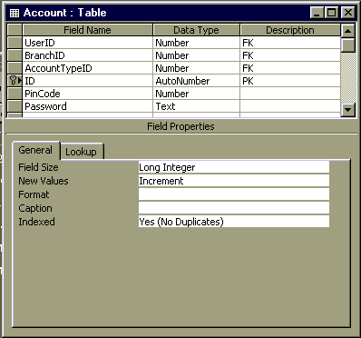 | 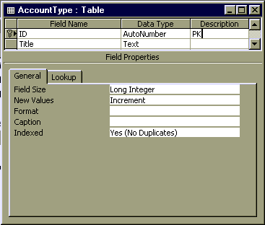
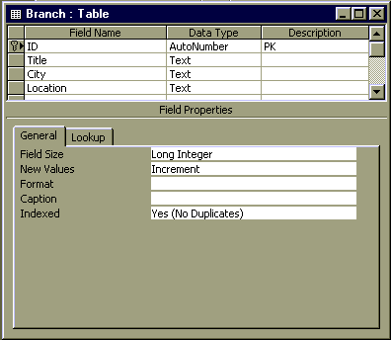 | 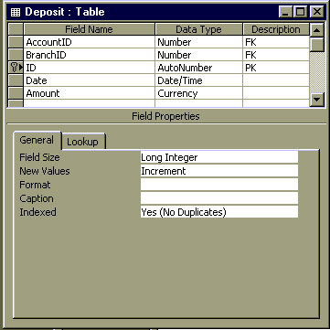
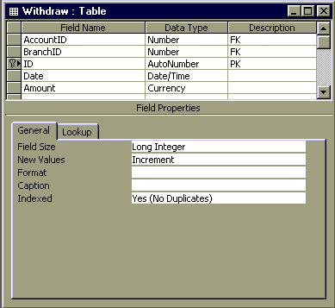 | 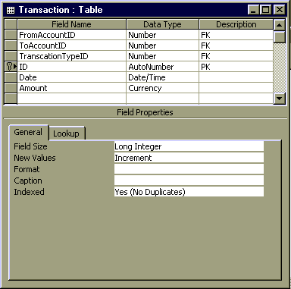
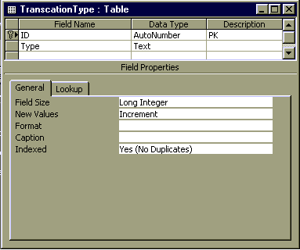 | 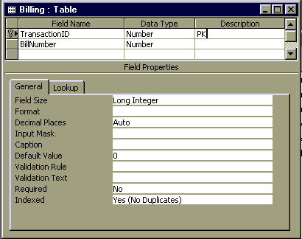
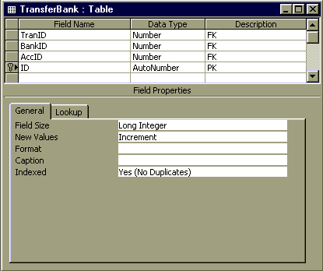

Screen / Report design Layout

Main page

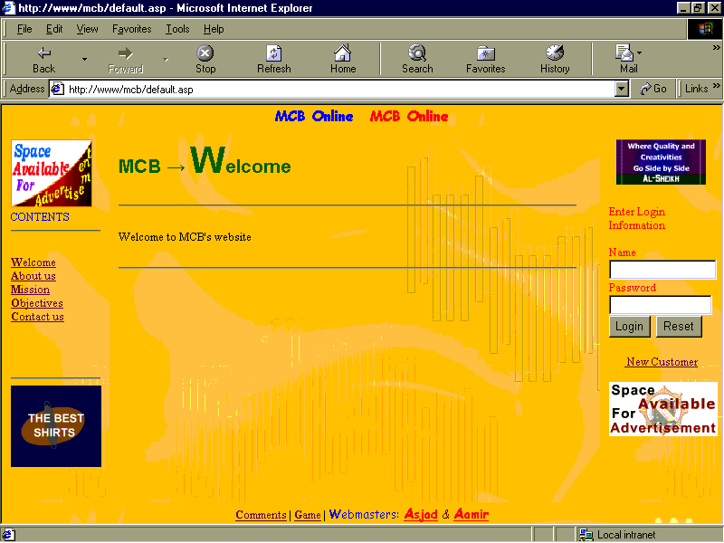

Account holder

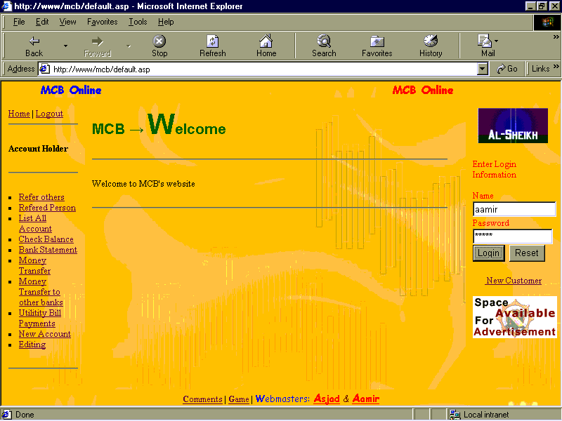

Refer to other

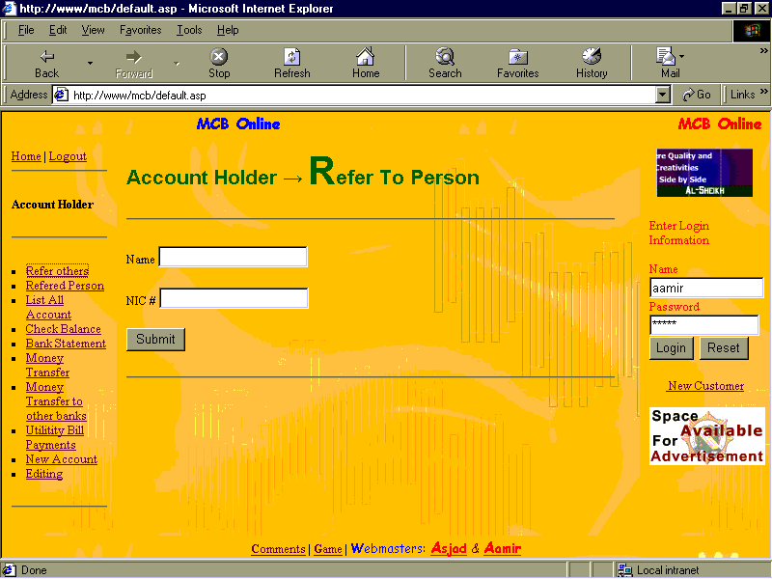

Referred person

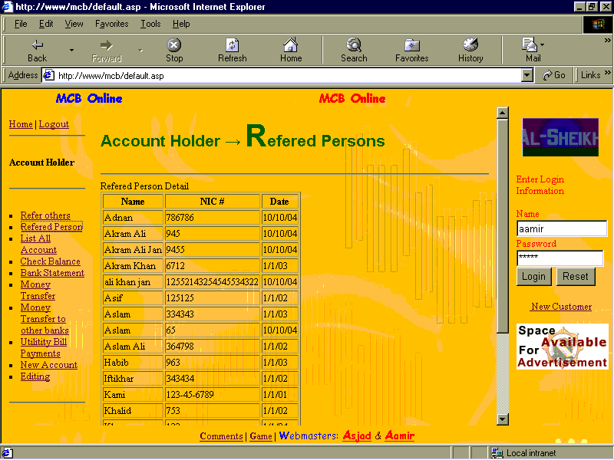

List of account

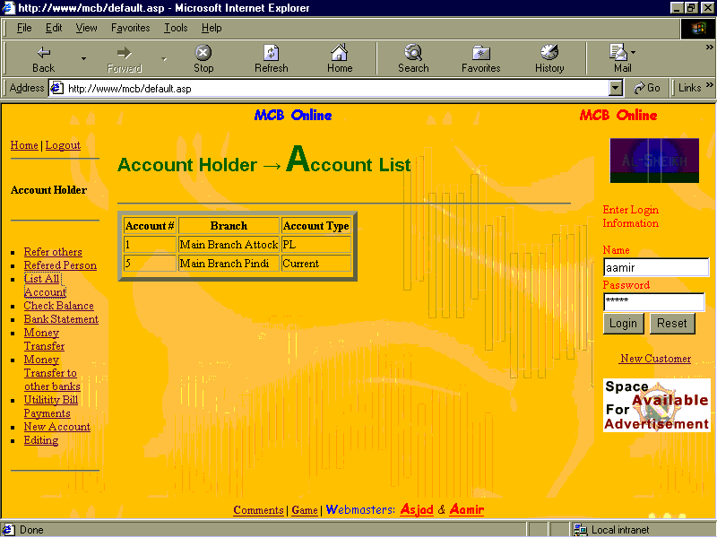

Check balance

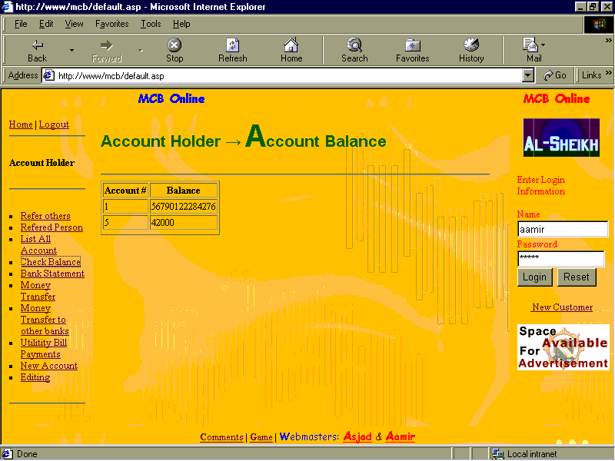

Money transfer

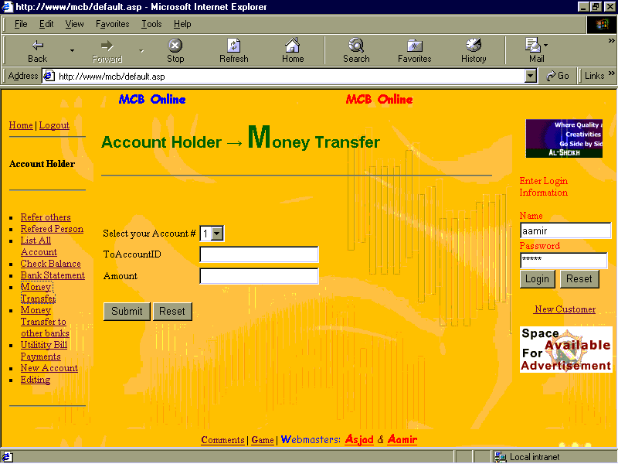

Money transfer to other bank

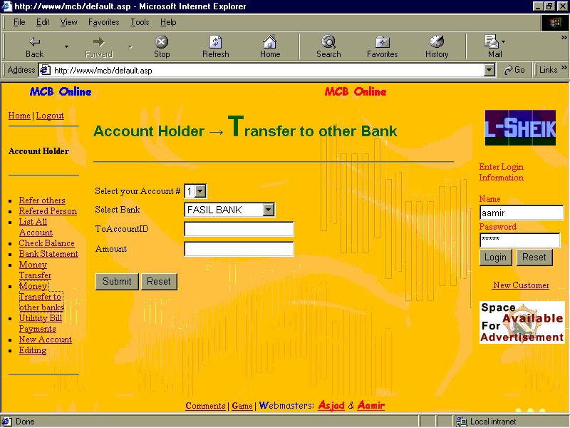

Bank statement

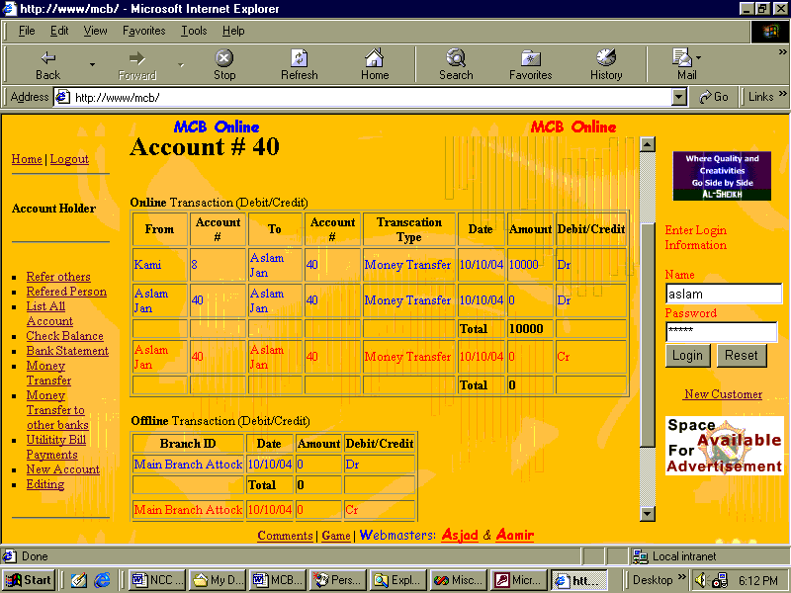

Bill payment

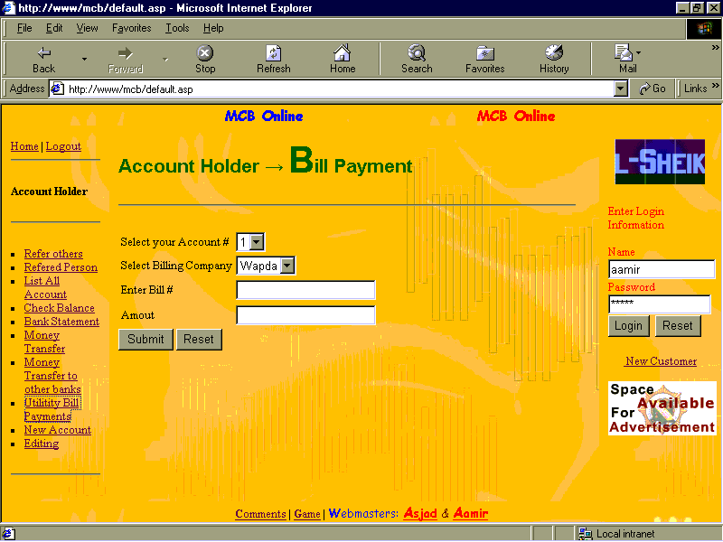

New account

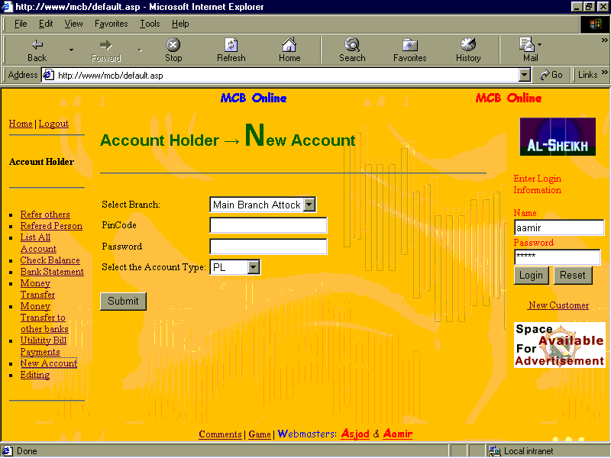

List of users for Administrator

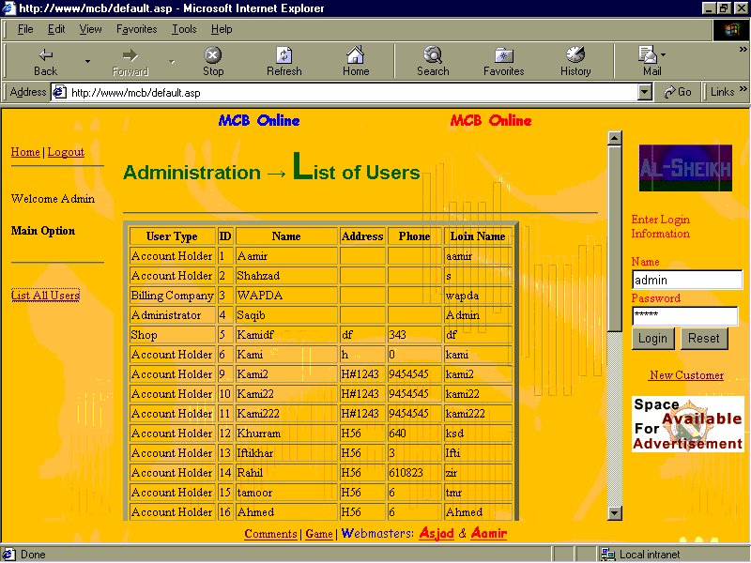

New customer

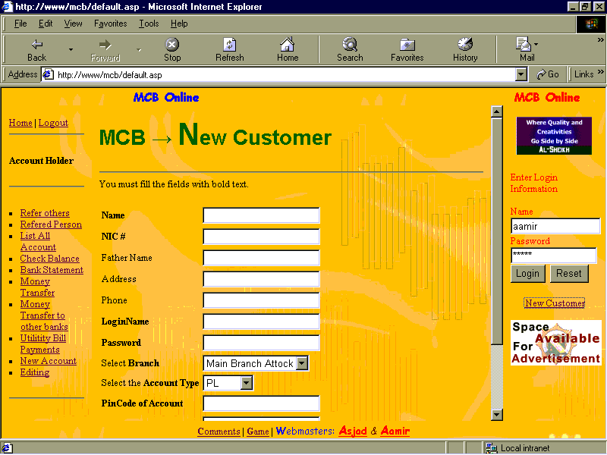

Editing option

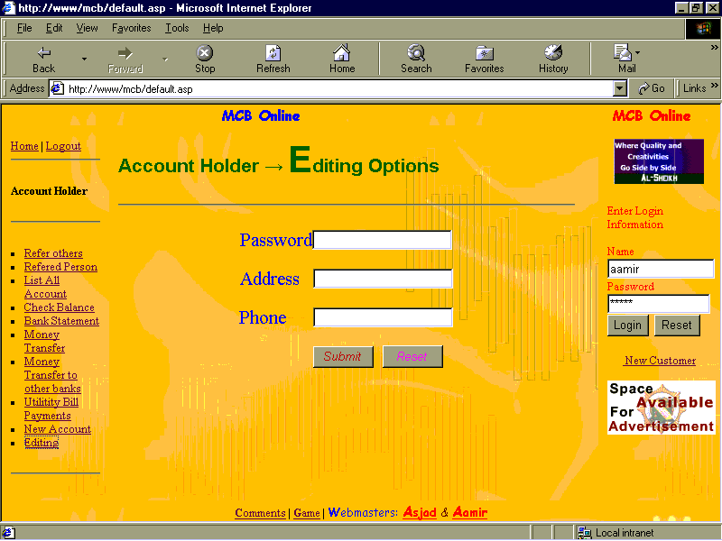

Company option

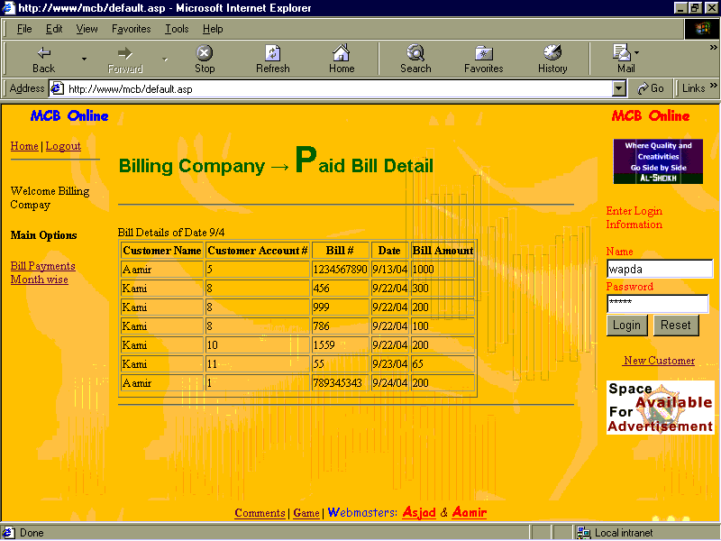

Shop transaction detail

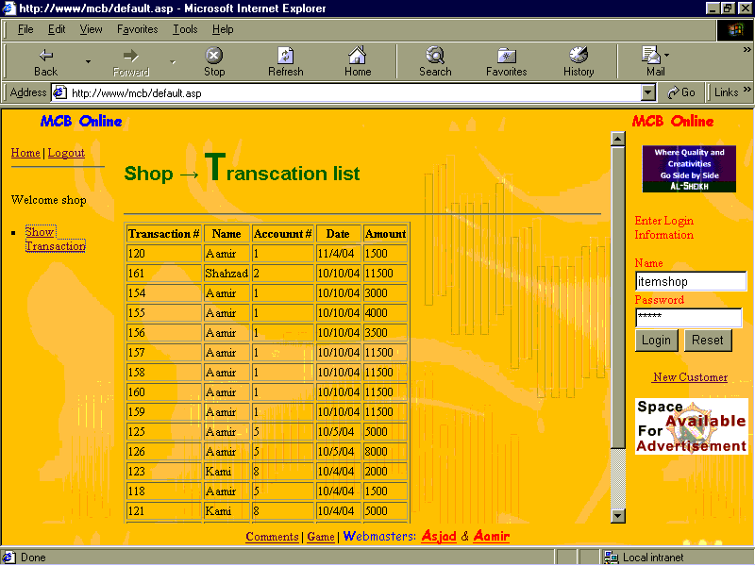

Appendices

Activity network analysis

Table
S# | Activity | Reference | Duration (Weeks) | Dependency
1 | Conduct feasibility study
 | Select the organization | A | 1 | Non
 | Visit the organization | B | 2 | A
 | Prepare report | C | 1 | A
2 | Carryout analysis
 | Study existing system | D | 1 | C, B
 | Problem identification | E | 1 | D
 | New system requirement | F | 2 | E
 | Layout of new system | G | 1 | E
 | List of application | H | 1 | E
 | Developing strategy | I | 1 | F, G, H
 | Prepare specification | J | 3 | I
3 | Design | K | 4 | J
4 | Detail design | L | 6 | J
5 | Development | M | 5 | L
6 | Testing & integration | N | 2 | L
7 | Training | O | 1 | N
8 | Implementation | P | 1 | N

Diagram
A
B
C
D
E
F
G
H
I
J
K
L
M
N
O
P

Activity network analysis description
Activity network allows us to schedule a project on the bases of table and diagram
In activity network some activities are done on parallel bases.

Supplier’s specifications

Introduction
This section contains information about software/hardware specification with supplier’s selection criteria.

Hardware supplier’s specification
Item | Company | Speed/size | Warranty Time | Quantity
Processor | Intel | 1.7 Ghz | 1 year | 6
Hard disk | Sea Gate | 40 GB | 1 year | 3
RAM |  | 255 | - | 2
Mouse | - | - | - | 2 (1 for backup)
Keyboard | Mercury | - | - | 2 (1 for backup)

Software supplier’s specification
Item | Company | Quality | Quantity | Reliability
Windows 2000 Advance Server | Microsoft | Advance | 1 | High
Visual Basic | Microsoft | Normal | 2 | Normal
MS-SQL Server (database) | Microsoft | Intermediate | 1 | High
IIS | Microsoft | Advance | 1 | High
Visual InterDev (for ASP) | Microsoft | Advance | 3 | Normal
Java Script | Sun Micro system | Normal | - (Free) | Low
VB Script | Microsoft | Normal | - (Free) | Low

Criteria Checklist for Supplier’s Selection
Name | Cost (40%) | Support (20%) | Deliver Time (10%) | Warranty (30%) | Total (100%)
Brains computer | 20 | 18 | 3 | 5 | 46
Khazina | 25 | 15 | 9 | 15 | 64
New PC World | 35 | 10 | 7 | 25 | 77
Star Computers | 15 | 12 | 10 | 20 | 57

Reason for selected supplier
According to criteria, we select the New PC World as a best supplier. Our main concern is cost and warranty. Although this supplier has low support but they are providing most inexpensive cost package for hardware and software. So we select this supplier.

Stakeholders’ communication

Introduction
Stakeholders are the people that are affected by organization. It is common that they communicate with each other. So here we list the stakeholders, how they communicate, on what occasion and why it is required to communicate.

Stakeholders table
Stakeholder | How | When (activity) | Why
1. Senior management | 1. Reports | C | 1. Allow management to take the decision
 | 2. Interview | E | 1 Problem Identification  2. Requirement specification
 | 3. Application /Letter | I | 1. To accept the project  2. To accept the change  3. Accept the software standard
2. Employees | 1. Observation | B | 1. Check the knowledge, requirement etc
 | 2. Meeting | D | 1. Study the system  2. Get requirements
 | 3. Questionnaire | E | 1. Get employee problem  2. Identify employees requirements
3. Suppliers | 1. Enquiry | F | 1. Get quotations
 | 2. Cheque (pay bill) | F | 1. Purchasing Hardware
 | 3. Letter | F | 1. Describing faults in items/hardware
 | 4. Warranty | F | 1. Return faulty items
 | 5. Phone | N | 1. Support/Query of items/
4. Customers | 1. Survey | E | 1. Identify requirements/problems
 | 2. Seminar | O | 1. To train customers  2. Tell him new features etc.

Activities reference
Activity | Reference | Activity | Reference
Select the organization | A | Developing strategy | I
Visit the organization | B | Prepare specification | J
Prepare report | C | Design | K
Study existing system | D | Detail design | L
Problem identification | E | Development | M
New system requirement | F | Testing & integration | N
Layout of new system | G | Training | O
List of application | H | Implementation | P

Coding

Global.asa
<SCRIPT LANGUAGE=VBScript RUNAT=Server>
Sub Session_onStart
Session("UserID") = 0
Session("UserType") = 0
Session("AccID") = 0
Session("Amount") = 0
Session("Msg") = ""
End Sub
</SCRIPT>

Default.asp
‘******************
‘ Main page
‘******************
<%@ Language=VBScript %>
<!-- #include file="Msg.asp" -->
<!DOCTYPE HTML PUBLIC "-//W3C//DTD HTML 4.0 Transitional//EN">
<HTML>
<HEAD>
<frameset rows="5%,,5%" border=0>
<frameset cols="50%,50%">
<frame src="top1.html" scrolling="no">
<frame src="top2.html" scrolling="no">
</frameset>
<frameset cols="15%,,17%">
<frame src="content.html" name="cont" scrolling="no">
<frame src="default.html" name="b">
<frame src="external.html" scrolling="no">
</frameset>
<frame src="bottom.html" scrolling="no">
</frameset>
</HEAD>
</HTML>

Msg.asp
<%
if Len( Session( "Msg" ) ) > 0 then
%>
<BODY background="b.jpg">
<%
Response.Write "<HR>"
Response.Write "<B>Message = </B>" & Session("Msg")
Response.Write "<HR>"
Session( "Msg" ) = ""
end if
%>

Top1.html
<HTML>
<HEAD>
</HEAD>
<BODY text="blue" topmargin="0" leftmargin="0" background="b.jpg">
<font face="Comic Sans MS">
<h3><marquee behavior="alternate" direction="right">MCB Online</marquee></h3>
</bont>
</BODY>
</HTML>

Top2.html
<HTML>
<HEAD>
</HEAD>
<BODY text="red" topmargin="0" leftmargin="0" background="b.jpg">
<font face="Comic Sans MS">
<h3><marquee behavior="alternate">MCB Online</marquee></h3>
</font>
</BODY>
</HTML>

Content.html
<HTML>
<HEAD>
</HEAD>
<BODY text="blue" background="b.jpg">
<IMG height=75 src="spad.gif" width=90>
<br>CONTENTS
<hr>
<P>
<A href="default.html" target=b><STRONG>W</STRONG>elcome</A><br>
<A href="aboutus.html" target=b><STRONG>A</STRONG>bout us</A><br>
<A href="MissionObjective.htm" target=b><STRONG>M</STRONG>ission</A><br>
<A href="MissionObjective.htm#Obj" target=b><STRONG>O</STRONG>bjectives</A><br>
<A href="contactus.html" target=b><STRONG>C</STRONG>ontact us</A></P>
<P>&nbsp;</P>
<hr>
<embed src="bnrr.swf" width=100 height=90>
</embed>
<P></P>
</BODY>
</HTML>

Default.html
<HTML>
<HEAD>
</HEAD>
<BODY background="b.jpg">
<font face="arial" color="green"><h2>
MCB &rarr; <FONT size=7>W</FONT>elcome</h2>
</font>
<hr>
<P>Welcome to MCB's website</P>
<hr>
</BODY>
</HTML>

External.html
<HTML>
<HEAD>
<META name=VI60_defaultClientScript content=VBScript>
<SCRIPT ID=clientEventHandlersJS LANGUAGE=vbscript>
<!--
function cmdSubmit_onclick()
if frmLogin.txtName.value = "" or _
frmLogin.txtPwd.value = "" then
msgbox "Fill all field"
exit function
end if
if len(frmLogin.txtPwd.value ) > 15 then
msgbox "Password length should be less than 16"
exit function
end if
‘*************************************************
‘ Code for Encryption
‘*************************************************
Dim OtherArr(3)
Randomize
TempString = ""
For i=0 To 3
OtherArr(i) = Int((9 * Rnd))
TempString = TempString & OtherArr(i)
Next
ThisText = frmLogin.txtPwd.value
For i=1 To Len(ThisText)
TempNum = Asc(Mid(ThisText,i,1))
If TempNum = 13 Then
TempNum = 28
ElseIf TempNum = 10 Then
TempNum = 29
End If
TempChar = Chr(TempNum - OtherArr(i Mod 4))
If TempChar = Chr(34) Then
TempChar = Chr(18)
End If
TempString = TempString & TempChar
Next
frmLogin.txtPwd.value = TempString
end function
//-->
</SCRIPT>
</HEAD>
<BODY text="red" background="b.jpg">
<center>
<embed src="bnr.swf" width="100" height="50">
</embed>
</center>
<FORM action="Login.asp" target="cont" method=post id=frmLogin name=frmLogin>
Enter Login Information<BR><BR>
Name <INPUT id=txtName name=txtName style="HEIGHT: 22px; WIDTH: 119px" maxLength=15><br>
Password <INPUT id=txtPwd name=txtPwd type=password style="HEIGHT: 22px; WIDTH: 114px" maxLength=15><br>
<INPUT id=cmdSubmit name=cmdSubmit type=submit value=Login>&nbsp;
<INPUT id=cmdReset name=cmdReset type=reset value=Reset><br><br>
</FORM>
<center>
<A href="frmNewCustomer.asp" target=b>&nbsp;New Customer</A><br><br>
<center>
<IMG src="spr.gif">
</center></center>
</BODY>
</HTML>

Bottom.html
<HTML>
<HEAD>
</HEAD>
<BODY topmargin="0" background="b.jpg">
<center>
<A href="comm.ents.html" target=b><STRONG>C</STRONG>omments</A> |
<A href="game.swf" target=b><STRONG>G</STRONG>ame</A> |
<font face="Comic Sans MS" color="blue"><STRONG>W</STRONG>ebmasters:
</font>
<font face="Comic Sans MS" color="red"><STRONG><U><FONT size=4>A</FONT>sjad</U></STRONG> <FONT color=maroon>&amp;</FONT> <STRONG><U><FONT size=4>A</FONT>amir</U></STRONG>
</font>
</center>
</BODY>
</HTML>

frmNewCustomer.asp
<!-- #include file="Msg.asp" -->
<!-- # include file="NavigatingMain.htm" -->
<HTML>
<HEAD>
<META NAME="GENERATOR" Content="Microsoft Visual Studio 6.0">
<TITLE></TITLE>
</HEAD>
<BODY background="b.jpg">
<font face="arial" color="green"><h1>
MCB &rarr; <FONT size=7>N</FONT>ew Customer</h1></font>
<hr>
You must fill the fields with bold text.
<FORM action=NewCustomer.asp id=frmNewCust name=frmNewCust METHOD=post>
<TABLE>
<TR><TD><STRONG>Name</STRONG></TD><TD><INPUT id=txtName name=txtName></TD></TR>
<TR><TD><STRONG>NIC #</STRONG></TD><TD><INPUT id=txtNIC name=txtNIC></TD></TR>
<TR><TD>Father Name</TD><TD><INPUT id=txtFName name=txtFName></TD></TR>
<TR><TD>Address</TD><TD><INPUT id=txtAddr name=txtAddr></TD></TR>
<TR><TD>Phone</TD><TD><INPUT id=txtPhone name=txtPhone></TD></TR>
<TR><TD><STRONG>LoginName</STRONG></TD><TD><INPUT id=txtLoginName name=txtLoginName></TD></TR>
<TR><TD><STRONG>Password</STRONG></TD><TD><INPUT id=txtPwd name=txtPwd type=password></TD></TR>
<TR><TD>Select <STRONG>Branch</STRONG></TD><TD><SELECT NAME=lstBranchID SIZE=1>
<%
dim Cn
set Cn = server.CreateObject("ADODB.Connection")
Cn.Open "DSN=dsnMCB"

dim oRs
set oRs = server.CreateObject("ADODB.recordset")
Dim sSQL
'sSQL = "SELECT * FROM Branch"
oRs.Open "Branch", Cn

while not oRs.EOF
Response.Write "<OPTION VALUE=" & oRs("ID") & ">" & oRs("Title") _
& "</OPTION>"
'Response.Write oRsAcc("Title") & "</OPTION>"
oRs.MoveNext
wend
oRs.Close
%>
</SELECT></TD></TR>

<TR><TD>Select the <STRONG>Account Type</STRONG></TD><TD><SELECT NAME=lstAccTypeID SIZE=1>
<%
oRs.Open "AccountType", Cn
while not oRs.EOF
Response.Write "<OPTION VALUE=" & oRs("ID") & ">"
Response.Write oRs("Title") & "</OPTION>"
oRs.MoveNext
wend
oRs.Close
%>
</select></TD></TR>

<TR><TD><STRONG>PinCode of Account</STRONG></TD><TD><INPUT id=txtPinCode name=txtPinCode></TD></TR>
<TR><TD><STRONG>Password of Account</STRONG></TD><TD><INPUT id=txtAccPwd name=txtAccPwd type=password></TD></TR>
<TR><TD></TABLE>
<P><INPUT id=cmdSubmit name=cmdSubmit type=submit value=Submit> <INPUT id=cmdReset name=cmdReset type=reset value=Reset></P></TD></TR>
<hr>
</FORM>
</BODY>
</HTML>

NewCustomer.asp
<!-- #include file="ADOvbs.inc" -->
<%
if Request.Form("txtName") = "" Or Request.Form("txtNIC") = "" _
Or Request.Form("txtLoginName") = "" Or Request.Form("txtPwd") = "" _
Or Request.Form("lstBranchID") = "" Or Request.Form("lstAccTypeID") = "" _
Or Request.Form("txtPinCode") = "" Or Request.Form("txtAccPwd") = "" then
session("Msg") = "You must fill the fields with bold lables"
Response.Redirect "frmNewCustomer.asp"
end if

dim Cn
set Cn = server.CreateObject("ADODB.Connection")
Cn.Open "DSN=dsnMCB"
Cn.BeginTrans

set oRsRef = server.CreateObject("ADODB.recordset")
strSQL = "SELECT * FROM ReferTo WHERE [NIC]='" & Request.Form("txtNIC") & "';"
'Response.Write "H1"
oRsRef.Open strSQL, Cn
'Response.Write oRsMax("MaxID")
'Response.Write "H2"
if not oRsRef.EOF then
'Response.Write oRsRef("UserID")
dim oRs
set oRs = server.CreateObject("ADODB.recordset")
oRs.Open "User", Cn,adOpenDynamic ,adLockPessimistic
oRs.AddNew
oRs("UserTypeID") = 1 'for Account Holder
'oRs("ID")= oRsMax("MaxID") + 1 'It is Auto# now
oRs("Name")= request.Form("txtName")
's
if Request.Form("txtAddr") <> "" then
oRs("Address")= Request.Form("txtAddr")
end if
'e
if Request.Form("txtPhone") <> "" then
oRs("Phone")= Request.Form("txtPhone")
end if

oRs("LoginName")= Request.Form("txtLoginName")

Dim Obj
Set Obj = CreateObject("pjtMyDll6.clsMyDll6")
Dim sStr
sStr = Request.Form("txtPwd")
sStr = Obj.Encript(CStr(sStr))

oRs("Password")= CStr(sStr)
oRs.Update
oRs.MoveLast
dim nUserID
nUserID = oRs("ID")
oRs.Close
oRs.Open "AccountHolder", Cn,adOpenDynamic ,adLockPessimistic
oRs.AddNew
oRs("ID") =nUserID
oRs("NIC")= Request.Form("txtNIC")
if Request.Form("txtFName") <> "" then
oRs("FatherName")= Request.Form("txtFName")
end if
oRs.Update
oRs.Close
's
'*************************
oRs.Open "Account", Cn,adOpenDynamic ,adLockPessimistic
oRs.AddNew
oRs("UserID") = nUserID
oRs("BranchID")= request.Form("lstBranchID")
oRs("AccountTypeID")= Request.Form("lstAccTypeID")
oRs("PinCode")= Request.Form("txtPinCode")
oRs("Password")= Request.Form("txtAccPwd")
oRs.Update
oRs.MoveLast
dim nAccID
nNewAccID = oRs("ID")
oRs.Close

'*****************************************************
oRs.Open "Deposit", Cn,adOpenDynamic ,adLockPessimistic
oRs.AddNew
oRs("AccountID")= nNewAccID
oRs("BranchID")= 1 'Request.Form("txtBID")
oRs("Date")= Date
oRs("Amount")= 0 'request.form("txtPC")
oRs.Update
oRs.Close

oRs.Open "Withdraw", Cn,adOpenDynamic ,adLockPessimistic
oRs.AddNew
oRs("AccountID")= nNewAccID
oRs("BranchID")= 1 'Request.Form("txtBID")
oRs("Date")= Date
oRs("Amount")= 0 'request.form("txtPC")
oRs.Update
oRs.Close

oRs.Open "Transaction", Cn,adOpenDynamic ,adLockPessimistic
oRs.AddNew
oRs("FromAccountID")= nNewAccID
oRs("ToAccountID")= nNewAccID 'Request.Form("txtBID")
oRs("TranscationTypeID")= 1 'transfer
oRs("Date")= Date
oRs("Amount")= 0 'request.form("txtPC")
oRs.Update
oRs.Close

Cn.CommitTrans
Cn.Close
'*****************************************************
'Response.Write "<BR>BID" & request.Form("lstBranchID")
'Response.Write "<BR>ATypeID" & Request.Form("lstAccTypeID")
%>
<!-- #include file="NavigatingMain.htm" -->
<%
Response.Write "<HR>" & request.Form("txtName")
Response.Write "'s Record is Added<HR>"
else
session("Msg") = "You have no reference"
Response.Redirect "frmNewCustomer.asp"
end if
%>

Login.asp
<%@ Language=VBScript %>
<%
if Request.Form("txtName") = "" or Request.Form("txtPwd") = "" then
Session("Msg") = "Fill all field"
Response.Redirect "default.asp"
Response.End
end if
set oRs = server.CreateObject("ADODB.recordset")
strSQL = "SELECT * FROM User WHERE LoginName='" _
& Request.Form("txtName") & "'"
oRs.Open strsql, "DSN=dsnMCB"
if not oRs.EOF and not ors.BOF then
Dim Obj 'As pjtMyDll.clsMyDll
Set Obj = CreateObject("pjtMyDll6.clsMyDll6")
Dim StrDB
StrDB = oRs("Password")
StrDB = Obj.Decript(CStr(StrDB))
Dim StrFrm
StrFrm = Request.Form("txtPwd")
StrFrm = Obj.Decript(CStr(StrFrm))
if StrDB = StrFrm then
'dim nCustTypeID 'check public
Session("UserID") = oRs("ID")
Session("UserType") = oRs("UserTypeID")
'Response.Write "isLogin = " & Session("islogin")
else
session("Msg") = "Invalid Password"
Session("UserID") = 0
Session("UserType")=0
end if
else
session("Msg") = "Invalid Login name"
Session("UserID") = 0
Session("UserType")=0
end if
oRs.Close
select case Session("UserType")
case 0 '
'session("Msg") = "Invalid Login name/Password"
Response.Redirect "default.asp"
case 1 'AccountHolder
Response.Redirect "AccountHolder.asp"
case 2
'Response.Write "Shop"
Response.Redirect "Shop.asp"
case 3
Response.Redirect "BillingComp.asp"
'Response.Write "Billing Company"
case 4
Response.Redirect "Admin.asp"
Response.Write "Admin"
case 5
Response.Write "Welcom Bank"
end select
%>

AccountHolder.asp
<!-- #include file="AuthenticateAccHolder.asp" -->
<!-- #include file="Msg.asp" -->
<HTML>
<HEAD>
<META NAME="GENERATOR" Content="Microsoft Visual Studio 6.0">
<TITLE></TITLE>
</HEAD>
<BODY background="b.jpg">
<!--#include file="MainNavigating.htm"-->
<P><STRONG>Account Holder</STRONG></P>
<HR>

<UL style="MARGIN-LEFT: 15px">
<LI><A href="frmReferTo.asp" target=b>Refer others</A> </LI>
<LI><A href="ListReferedPerson.asp" target=b>Refered Person</A> </LI>
<LI><A href="ListAccount.asp" target=b>List All Account</A> </LI>
<LI><A href="AccountBalance.asp" target=b>Check Balance</A> </LI>
<LI><A href="frmSelectAccountBS.asp" target=b>Bank Statement</A> </LI>
<LI><A href="frmTransfer.asp" target=b>Money Transfer</A> </LI>
<LI><A href="frmTransferBank.asp" target=b>Money Transfer to other
banks</A> </LI>
<LI><A href="frmBill.asp" target=b>Utilitity Bill Payments</A> </LI>
<LI><A href="frmNewAccount.asp" target=b>New Account</A> </LI>
<LI><A href="frmEditing.asp" target=b>Editing</A> </LI></UL>
<HR>
</BODY>
</HTML>

frmReferTo.asp
<!-- #include file="AuthenticateAccHolder.asp" -->
<!-- #include file="Msg.asp" -->
<HTML>
<HEAD>
<META name=VI60_defaultClientScript content=VBScript>
<META NAME="GENERATOR" Content="Microsoft Visual Studio 6.0">
<TITLE></TITLE>
<SCRIPT ID=clientEventHandlersVBS LANGUAGE=vbscript>
<!--

Sub frmRefTo_onsubmit
dim strErr
strErr = ""
if frmRefTo.txtName.value = "" or _
frmRefTo.txtNIC.value = "" then
strErr = strErr & "Fill all field. "
end if
if IsNumeric(frmrefto.txtName.value) then
strErr = strErr & "Enter valid name. "
end if

if len(strErr) > 0 then
frmRefTo.action =""
MsgBox strErr
end if
End Sub

-->
</SCRIPT>
</HEAD>
<BODY background="b.jpg">
<!-- # include file="NavigatingAccHolder.htm" -->
<font face="arial" color="green"><h2>
Account Holder &rarr; <FONT size=7>R</FONT>efer To Person</h2></font>
<hr>
<FORM action="ReferTo.asp" id=frmRefTo method=post name=frmRefTo>
<P>Name <INPUT id=txtName name=txtName maxLength=20></P>
<P>NIC # <INPUT id=txtNIC name=txtNIC maxLength=20></P>
<P><INPUT id=cmdSubmit name=cmdSubmit type=submit value=Submit></P>
</FORM>
<hr>
</BODY>
</HTML>

ListReferedPerson.asp
<%@ Language=VBScript %>
<body background="b.jpg">
<!-- # include file="NavigatingAccHolder.htm" -->
<font face="arial" color="green"><h2>
Account Holder &rarr; <FONT size=7>R</FONT>efered Persons</h2></font>
<hr>
<%
dim oRs
set oRs = server.CreateObject("ADODB.recordset")
'Response.Write "H1"
dim sSQL
sSQL = "SELECT Name, NIC, [Date] FROM ReferTo WHEREUserID = “
& Session("UserID") & " ORDER BY Name"
oRs.Open sSQL,"DSN=dsnMCB"
Response.Write "Refered Person Detail"
Response.Write "<TABLE BORDER=1>"
Response.Write "<TR><TH><B>Name</B></TH><TH><B>NIC
#</B></TH><TH><B>Date</B></TH></TR><TR><TD>"
if not oRs.EOF then
Response.Write oRs.GetString
(,,"</TD><TD>","</TD></TR><TR><TD>","&nbsp;")
end if
Response.Write "</TD></TR></TABLE>"
oRs.Close
%>
<hr>
<body>

ListAccount.asp
<!-- #include file="AuthenticateAccHolder.asp" -->
<body background="b.jpg">
<!-- # include file="NavigatingAccHolder.htm" -->
<%
set oRs = server.CreateObject("ADODB.recordset")
Dim strSQL
strSQL = "SELECT Account.ID, Branch.Title, AccountType.Title " & _
"FROM AccountType INNER JOIN (Branch INNER JOIN “ & _
“ Account ON " & _
"Branch.ID =Account.BranchID) ON " & _
"AccountType.ID = Account.AccountTypeID " & _
"WHERE Account.UserID=" & Session("UserID")
oRs.Open strSQL, "DSN=dsnMCB"
''''''
%>
<font face="arial" color="green"><h2>
Account Holder &rarr; <FONT size=7>A</FONT>ccount List</h2></font>
<hr>
<%
Response.Write "<TABLE BORDER=5>"
Response.Write "<TR><TH>Account #</TH><TH>Branch</TH><TH>Account Type</TH></TR><TR><TD>"
Response.Write oRs.GetString(,,"</TD><TD>","</TD></TR><TR><TD>","&nbsp;")
Response.Write "</TD></TR></TABLE>"
oRs.Close
%>

AccountBalance.asp
<!-- #include file="AuthenticateUser.asp" -->
<!-- #include file="ADOvbs.inc" -->
<!-- # include file="NavigatingAccHolder.htm" -->
<body background="b.jpg">
<%
dim oCon
set ocon = server.CreateObject("ADODB.Connection")
oCon.Open "DSN=dsnMCB"

Dim oCmd
Set oCmd = Server.CreateObject("ADODB.Command")
oCmd.ActiveConnection = oCon
oCmd.CommandText = "qFindBalance"
oCmd.CommandType = adCmdStoredProc

dim oParm
set oParm = server.CreateObject("ADODB.Parameter")
oParm.Name ="AID"
oParm.Type=adInteger
oParm.Direction = adParamInput
oCmd.Parameters.Append oParm
dim oRsBal
set oRsBal = server.CreateObject("ADODB.recordset")
dim oRsAcc
set oRsAcc = server.CreateObject("ADODB.recordset")
dim sSql
sSql="select * from Account where UserID=" & Session("UserID")
oRsAcc.Open sSql,oCon
'Response.Write "<BR>1. EOF = " & oRsAcc.EOF
'Response.Write "<BR>1. BOF = " & oRsAcc.BOF
'Remove this because each customer must have 1 bank account
if oRsAcc.EOF or oRsAcc.BOF then
Response.Write "No Account"
end if
%>
<font face="arial" color="green"><h2>
Account Holder &rarr; <FONT size=7>A</FONT>ccount
Balance</h2></font>
<hr>
<%
'Response.Write "<H1>Balance of All Account</H1>"
Response.Write "<TABLE BORDER=1>"
Response.Write "<TR><TH>Account
#</TH><TH>Balance</TH></TR><TR><TD>"
while not oRsAcc.EOF
oParm.Value = oRsAcc("ID")
set oRsBal = oCmd.Execute
if not oRsBal.EOF then ' or not oRsBal.BOF
Response.Write oRsAcc("ID") & "</TD><TD>"
Response.Write oRsBal.GetString(,,"</TD></TR>",
"<TR><TD>","&nbsp;")
''Response.Write oRs.GetString(,,"</TD><TD>","</TD></TR><TR><TD>","&nbsp;")
'Response.Write "</TD></TR></TABLE>"
oRsAcc.MoveNext
end if
oRsBal.Close
wend
Response.Write "</TD></TR></TABLE>"
oRsAcc.Close
oCon.Close
%>
</body>

FrmSelectAccountBS.asp
<!-- #include file="AuthenticateAccHolder.asp" -->
<!-- #include file="Msg.asp" -->
<%
dim oRsAcc
set oRsAcc = server.CreateObject("ADODB.recordset")
Dim sSQL
sSQL = "SELECT * FROM Account WHERE UserID = " &
Session("UserID")
oRsAcc.Open sSQL, "DSN=dsnMCB"
%>
<HTML>
<HEAD>
<META name=VI60_defaultClientScript content=VBScript>
<META NAME="GENERATOR" Content="Microsoft Visual Studio 6.0">
<SCRIPT ID=clientEventHandlersVBS LANGUAGE=vbscript>
<!--

Sub FORM1_onsubmit
if Not IsNumeric(form1.lstAccID.value) then
msgbox "Enter Only Numeric Value"
form1.action=""
end if
End Sub

-->
</SCRIPT>
</HEAD>
<BODY background="b.jpg">
<font face="arial" color="green"><h2>
Account Holder &rarr; <FONT size=7>S</FONT>elect Account</h2></font>
<hr>
<!-- # include file="NavigatingAccHolder.htm" -->
<FORM action="BankStatement.asp" id=FORM1 method=post name=FORM1>
<P>Select an Account #
<SELECT NAME=lstAccID SIZE=1>
<%
while not oRsAcc.EOF
Response.Write "<OPTION VALUE=" & oRsAcc("ID") & ">"
Response.Write oRsAcc("ID") & "</OPTION>"
oRsAcc.MoveNext
wend
oRsAcc.Close
%>
</SELECT>
</P>
<P><INPUT id=submit name=submit type=submit value=Submit>
<INPUT id=reset name=reset type=reset value=Reset></P>
</FORM>

</BODY>
</HTML>

BankStatement.asp
<!-- #include file="AuthenticateAccHolder.asp" -->
<%
if Request.Form("lstAccID") = "" then
session("Msg") = "Invalid Account #. You must select an Account # to
see bank statment"
Response.Redirect "frmSelectAccountBS.asp"
end if
%>
<!-- #include file="ADOvbs.inc" -->
<body background="b.jpg">
<font face="arial" color="green"><h2>
Account Holder &rarr; <FONT size=7>B</FONT>ank Statment</h2></font>
<hr>
<%
dim oCon
set ocon = server.CreateObject("ADODB.Connection")
oCon.Open "DSN=dsnMCB"

dim oRs
set oRs = server.CreateObject("ADODB.recordset")

Response.Write "<H1>Account # " & Request.Form("lstAccID") &
"</H1>"

'Transaction In Amount
sSQL="SELECT User.Name,Transaction.FromAccountID,User_1.Name, " _
& "Transaction.ToAccountID, TranscationType.Type, Transaction.Date, "_
& "Transaction.Amount FROM [User] AS User_1 INNER JOIN (Account AS Account_1 "_
& "INNER JOIN (([User] INNER JOIN Account ON User.ID = Account.UserID) "_
& "INNER JOIN (TranscationType INNER JOIN [Transaction] ON "_
& "TranscationType.ID = Transaction.TranscationTypeID) ON "_
& "Account.ID = Transaction.FromAccountID) ON Account_1.ID = "_
& "Transaction.ToAccountID) ON User_1.ID = Account_1.UserID "_
& "WHERE (((Transaction.ToAccountID)= " & Request.Form("lstAccID") _
& ")) ORDER BY Transaction.Date;"
oRs.Open sSQL, oCon
Response.Write "<BR><B>Online</B> Transaction (Debit/Credit)"
Response.Write "<TABLE BORDER=1>"
Response.Write "<TR><TH>From</TH><TH>Account #</TH><TH>To</TH><TH>Account #</TH><TH>Transcation Type</TH><TH>Date</TH><TH>Amount</TH><TH>Debit/Credit</TH></TR><TR><TD><FONT color=blue>"
if not oRs.EOF then
Response.Write oRs.GetString(,,"</TD><TD><FONT color=blue>","</TD><TD><FONT color=blue>Dr</TD></TR><TR><TD><FONT color=blue>","&nbsp;")
end if
'Response.Write "</TD></TR></TABLE><HR>"
oRs.Close
'calc total amount
sSQL="SELECT Sum(Transaction.Amount) AS Total " _
& "FROM [Transaction] GROUP BY Transaction.ToAccountID " _
& "HAVING (((Transaction.ToAccountID)=" & Request.Form("lstAccID") & "));"
oRs.Open sSQL, oCon
'if not oRs.EOF then
Response.Write "&nbsp;</TD><TD>&nbsp;</TD><TD>&nbsp;</TD><TD>&nbsp;</TD><TD>&nbsp;</TD><TD><B>Total</B></TD><TD><B>"
Response.Write oRs("Total")
Response.Write "</B></TD><TD>&nbsp;</TD></TR><TR><TD><FONT color=red>"
'end if
'Response.Write "</TD></TR></TABLE><HR>"
oRs.Close
'eeeeeeeeeeeee

'Transaction out Amount
'sSQL="SELECT * FROM Transaction WHERE FromAccountID=" & oRsAcc("ID")'& Session("CustID")
'sSQL="SELECT Transaction.FromAccountID, Transaction.ToAccountID, " _
'& "TranscationType.Type, Transaction.Date, Transaction.Amount " _
'& "FROM TranscationType INNER JOIN [Transaction] ON TranscationType.ID = " _
'& "Transaction.TranscationTypeID WHERE (((Transaction.FromAccountID)=" _
'& Request.Form("lstAccID") & "));"

'sssssssssssssssssssssssssssssssssssssssssssssssssssssssssssssssssss
sSQL="SELECT User.Name, Transaction.FromAccountID, User_1.Name, " _
& "Transaction.ToAccountID, TranscationType.Type, Transaction.Date, "_
& "Transaction.Amount FROM [User] AS User_1 INNER JOIN (Account AS Account_1 "_
& "INNER JOIN (([User] INNER JOIN Account ON User.ID = Account.UserID) "_
& "INNER JOIN (TranscationType INNER JOIN [Transaction] ON "_
& "TranscationType.ID = Transaction.TranscationTypeID) ON "_
& "Account.ID = Transaction.FromAccountID) ON Account_1.ID = "_
& "Transaction.ToAccountID) ON User_1.ID = Account_1.UserID "_
& "WHERE (((Transaction.FromAccountID)= " & Request.Form("lstAccID") _
& ")) ORDER BY Transaction.Date;"
'eeeeeeeeeeeeeeeeeeeeeeeeeeeeeeeeeeeeeeeeeeeeeeeeeeeeeeeeeeeeeeeeeee

oRs.Open sSQL, oCon
'Response.Write "<BR>Transaction Out Amount"
'Response.Write "<TABLE BORDER=1>"
'Response.Write "<TR><TH>FromAccountID</TH><TH>ToAccountID</TH><TH>TranscationTypeID</TH><TH>ID</TH><TH>Date</TH><TH>Amount</TH></TR><TR><TD>"
'Response.Write "---------=======--------</TD>/TR><TR><TD>"

'Response.Write "&nbsp;</TD><TD>&nbsp;</TD><TD>&nbsp;</TD><TD>&nbsp;</TD><TD>&nbsp;</TD><TD>&nbsp;</TD><TD>&nbsp;</TD><TD>&nbsp;</TD></TR><TR><TD>"
'Response.Write "&nbsp;</TD></TR><TR><TD>"
if not oRs.EOF then
Response.Write oRs.GetString(,,"</TD><TD><FONT color=red>","</TD><TD><FONT color=red>Cr</TD></TR><TR><TD><FONT color=red>","&nbsp;")
end if
oRs.Close
'sssssss
'total cr
sSQL="SELECT Sum(Transaction.Amount) AS Total " _
& "FROM [Transaction] GROUP BY Transaction.FromAccountID " _
& "HAVING (((Transaction.FromAccountID)=" & Request.Form("lstAccID") & "));"
oRs.Open sSQL, oCon
'if not oRs.EOF then
Response.Write "&nbsp;</TD><TD>&nbsp;</TD><TD>&nbsp;</TD><TD>&nbsp;</TD><TD>&nbsp;</TD><TD><B>Total</B></TD><TD><B>"
Response.Write oRs("Total")
Response.Write "</B></TD><TD>&nbsp;</TD></TR><TABLE>"
'end if
'Response.Write "</TD></TR></TABLE><HR>"
oRs.Close
'eeeeee
'Response.Write "</TD></TR></TABLE>"

'Deposit
'sSQL="SELECT * FROM Deposit WHERE AccountID=" & oRsAcc("ID")'& Session("CustID")
sSQL="SELECT Branch.Title, Deposit.Date, Deposit.Amount " _
& "FROM Branch INNER JOIN Deposit ON Branch.ID = Deposit.BranchID " _
& "WHERE (((Deposit.AccountID)=" & Request.Form("lstAccID") & "));"

oRs.Open sSQL, oCon
Response.Write "<BR><B>Offline</B> Transaction (Debit/Credit)"
'Response.Write "<BR>Offline Amounts "
Response.Write "<TABLE BORDER=1>"
Response.Write "<TR><TH>Branch ID</TH><TH>Date</TH><TH>Amount</TH><TH>Debit/Credit</TH></TR><TR><TD><FONT color=blue>"
if not oRs.EOF then
Response.Write oRs.GetString(,,"</TD><TD><FONT color=blue>","</TD><TD><FONT color=blue>Dr</TD></TR><TR><TD><FONT color=blue>","&nbsp;")
end if
'Response.Write "</TD></TR></TABLE><HR>"
oRs.Close

'ssssssss
'total deposit
sSQL="SELECT Sum(Deposit.Amount) AS Total FROM Deposit " _
& "GROUP BY Deposit.AccountID HAVING (((Deposit.AccountID)=" _
& Request.Form("lstAccID") & "));"

oRs.Open sSQL, oCon

Response.Write "&nbsp;</TD><TD><B>Total</B></TD><TD><B>"
Response.Write oRs("Total")
Response.Write "</B></TD><TD>&nbsp;</TD></TR><TR><TD><FONT color=red>"

oRs.Close
'eeeeee

'Withdraw
'sSQL="SELECT * FROM Withdraw WHERE AccountID=" & oRsAcc("ID")'& Session("CustID")
sSQL="SELECT Branch.Title, Withdraw.Date, Withdraw.Amount " _
& "FROM Branch INNER JOIN Withdraw ON Branch.ID = Withdraw.BranchID " _
& "WHERE (((Withdraw.AccountID)=" & Request.Form("lstAccID") & "));"
oRs.Open sSQL, oCon
'Response.Write "<BR>Withdraw Amounts"
'Response.Write "<TABLE BORDER=1>"
'Response.Write "<TR><TH>Account ID</TH><TH>Branch ID</TH><TH>ID</TH><TH>Date</TH><TH>Amount</TH></TR><TR><TD>"
'Response.Write "-</TD><TD>-</TD><TD>-</TD><TD>-</TD></TR><TR><TD>"
'Response.Write "</TD>/TR><TR><TD>"
Response.Write "</TD><TD></TD><TD></TD><TD></TD></TR><TR><TD><FONT color=red>"
'Response.Write "&nbsp;</TD><TD>&nbsp;</TD><TD>&nbsp;</TD><TD>&nbsp;</TD></TR><TR><TD>"
if not oRs.EOF then
Response.Write oRs.GetString(,,"</TD><TD><FONT color=red>","</TD><TD><FONT color=red>Cr</TD></TR><TR><TD><FONT color=red>","&nbsp;")
end if
'Response.Write "</TD></TR></TABLE>"
oRs.Close

'ssssssssssss
sSQL="SELECT Sum(Withdraw.Amount) AS Total FROM Withdraw " _
& "GROUP BY Withdraw.AccountID " _
& "HAVING (((Withdraw.AccountID)= " & Request.Form("lstAccID") &"));"
oRs.Open sSQL, oCon
'if not oRs.EOF then
Response.Write "&nbsp;</TD><TD><B>Total</B></TD><TD><B>"
Response.Write oRs("Total")
Response.Write "</B></TD><TD>&nbsp;</TD></TR><TABLE>"
'end if
'Response.Write "</TD></TR></TABLE><HR>"
oRs.Close
'eeeeeeeeeeee

'ssssssssssssssss
Dim oCmd
Set oCmd = Server.CreateObject("ADODB.Command")
oCmd.ActiveConnection = oCon
oCmd.CommandText = "qFindBalance"
oCmd.CommandType = adCmdStoredProc

dim oParm
set oParm = server.CreateObject("ADODB.Parameter")
oParm.Name ="AID"
oParm.Type=adInteger
oParm.Direction = adParamInput
oParm.Value = Request.Form("lstAccID")
oCmd.Parameters.Append oParm
'eeeeeeeeeeeeeeee

'sssssssss
set oRs = oCmd.Execute
'esponse.Write "<BR>1. EOF = " & oRsBal.EOF
'esponse.Write "<BR>1. BOF = " & oRsBal.BOF
if not oRs.EOF then ' or not oRsBal.BOF

Response.Write "<BR><H2>Account Balance = " & oRs("Balance") & "</H2>"
'Response.Write "<BR>Session('UserID') = " & Session("UserID") & "<BR>"
'Response.Write "Account Balance"
'Response.Write "<TABLE BORDER=1>"
'Response.Write "<TR><TH>Balance</TH></TR><TR><TD>"
'Response.Write oRs.GetString(,,"</TD><TD>","</TD></TR><TR><TD>","&nbsp;")
'Response.Write "</TD></TR></TABLE>"
end if
oRs.Close
'eeeeeeeeee

'oRsAcc.MoveNext
'wend

'RsAcc.Close
oCon.Close
%>

FrmTransfer.asp
<!-- #include file="AuthenticateAccHolder.asp" -->
<!-- #include file="Msg.asp" -->
<HTML>
<HEAD>
<META name=VI60_defaultClientScript content=VBScript>
<META NAME="GENERATOR" Content="Microsoft Visual Studio 6.0">
<TITLE></TITLE>
<SCRIPT ID=clientEventHandlersVBS LANGUAGE=vbscript>
<!--

Sub FORM1_onsubmit
if not IsNumeric(form1.txtToAccID.value ) or _
not IsNumeric(form1.txtAmount.value ) or _
not IsNumeric(form1.lstAcc.value) then
msgbox "Enter Numeric Value"
form1.action =""
end if
End Sub

-->
</SCRIPT>
</HEAD>
<BODY background="b.jpg">
<font face="arial" color="green"><h2>
Account Holder &rarr; <FONT size=7>M</FONT>oney Transfer</h2></font>
<hr>
<FORM action="Transfer.asp" id=FORM1 method=post name=FORM1>
<P>&nbsp;</P>
<table>
<tr><td>Select your Account #</td><td><SELECT NAME=lstAcc SIZE=1>
<%
dim oRsAcc
set oRsAcc = server.CreateObject("ADODB.recordset")
Dim sSQL
sSQL = "SELECT * FROM Account WHERE UserID = " & Session("UserID")
oRsAcc.Open sSQL, "DSN=dsnMCB"

while not oRsAcc.EOF
Response.Write "<OPTION VALUE=" & oRsAcc("ID") & ">"
Response.Write oRsAcc("ID") & "</OPTION>"
oRsAcc.MoveNext
wend
oRsAcc.Close
%>
</SELECT>
</td></tr>
<tr><td>ToAccountID</TD><td><INPUT id="txtToAccID" name="txtToAccID" maxlength=9></td></tr>
<tr><td>Amount</td><td><INPUT id="txtAmount" name="txtAmount" maxlength=14></td></tr>
</table>

<P>&nbsp;<INPUT id=submit name=submit type=submit value=Submit style="LEFT: 13px; TOP: 182px">&nbsp;<INPUT id=reset name=reset type=reset value=Reset></P>
</FORM>

</BODY>
</HTML>

Transfer.asp
<!-- #include file="AuthenticateUser.asp" -->
<!-- #include file="ADOvbs.inc" -->
<%
if CCur(Request.Form("txtAmount")) <= 0 then
Session( "Msg" ) = "Amount should not be <= 0"
Response.Redirect "frmTransfer.asp"
end if
dim oCon
set ocon = server.CreateObject("ADODB.Connection")
oCon.Open "DSN=dsnMCB"

Dim oCmd
Set oCmd = Server.CreateObject("ADODB.Command")
oCmd.ActiveConnection = oCon
oCmd.CommandText = "qFindBalance"
oCmd.CommandType = adCmdStoredProc

dim oParm
set oParm = server.CreateObject("ADODB.Parameter")
oParm.Name ="AID"
oParm.Type=adInteger
oParm.Direction = adParamInput
oParm.Value = Request.Form("lstAcc")
oCmd.Parameters.Append oParm

dim oRsBal
set oRsBal = server.CreateObject("ADODB.recordset")
set oRsBal = oCmd.Execute
'sdfsdfsdfsdfsd
'Response.Write oRsBal("Balance") & " >= " & Request.Form("txtAmount") & " = "
'Response.Write ( cint( oRsBal("Balance") ) >= cint( Request.Form("txtAmount") ) )
'Response.End
'dfsdfsdfsdfsdfsf
if CCur( oRsBal("Balance")) >= CCur( Request.Form("txtAmount") ) _
then
dim oRsTran
set oRsTran = server.CreateObject("ADODB.recordset")
oRsTran.Open "Transaction", oCon, adOpenDynamic ,adLockPessimistic
orsTran.AddNew
oRsTran("FromAccountID")= Request.Form("lstAcc") 'Request.Form("txtFromAccID")
oRsTran("ToAccountID")=Request.Form("txtToAccID")
oRsTran("TranscationTypeID")= 1 '--> transfer
oRsTran("Date")= date
oRsTran("Amount")= Request.Form("txtAmount")
oRsTran.Update
oRsTran.Close
%>
<BODY background="b.jpg">
<%
Response.Write "<HR>Transcation is complete<HR>"
else
Session( "Msg" ) = "There is only Rs " & CCur( oRsBal("Balance")) _
& " in balance while amount transfering is Rs " _
& CCur( Request.Form("txtAmount") )
Response.Redirect "frmTransfer.asp"
end if
oRsBal.Close
oCon.Close
%>

FrmBill.asp
<!-- #include file="AuthenticateAccHolder.asp" -->
<!-- #include file="Msg.asp" -->

<HTML>
<HEAD>
<META name=VI60_defaultClientScript content=VBScript>
<META NAME="GENERATOR" Content="Microsoft Visual Studio 6.0">
<TITLE></TITLE>
<SCRIPT ID=clientEventHandlersVBS LANGUAGE=vbscript>
<!--

Sub FORM1_onsubmit
if not IsNumeric(form1.lstFromAccID.value) or _
not IsNumeric(form1.txtBillNo.value) or _
not IsNumeric(form1.txtAmount.value) then
msgbox "Enter Numeric Value"
form1.action =""
end if

if form1.lstComID.value = "" then
msgbox "Your must select a billing company"
form1.action =""
end if
End Sub

-->
</SCRIPT>
</HEAD>
<BODY background="b.jpg">
<font face="arial" color="green"><h2>
Account Holder &rarr; <FONT size=7>B</FONT>ill Payment</h2></font>
<hr>
<!-- # include file="NavigatingAccHolder.htm" -->
<!--'<h1>Bill payments options</h1>-->
<FORM action="Bill.asp" id=FORM1 method=post name=FORM1>
<table>
<Tr><td>Select your Account #</td><td><SELECT NAME=lstFromAccID SIZE=1>
<%
dim Cn
set Cn = server.CreateObject("ADODB.Connection")
Cn.Open "DSN=dsnMCB"

dim oRsAcc
set oRsAcc = server.CreateObject("ADODB.recordset")
Dim sSQL
sSQL = "SELECT * FROM Account WHERE UserID = " & Session("UserID")
oRsAcc.Open sSQL, Cn

while not oRsAcc.EOF
Response.Write "<OPTION VALUE=" & oRsAcc("ID") & ">"
Response.Write oRsAcc("ID") & "</OPTION>"
oRsAcc.MoveNext
wend
oRsAcc.Close
%>
</SELECT>
</td></tr>

<tr><td>Select Billing Company</td><td><SELECT NAME=lstComID SIZE=1>
<%
dim oRsCom
set oRsCom = server.CreateObject("ADODB.recordset")
'Dim sSQL
'sSQL = "SELECT * FROM BillingCompany WHERE ID = " & Session("UserID")
oRsCom.Open "BillingCompany", Cn

while not oRsCom.EOF
Response.Write "<OPTION VALUE=" & oRsCom("ID") & ">"
Response.Write oRsCom("Title") & "</OPTION>"
oRsCom.MoveNext
wend
oRsCom.Close
%>
</SELECT>
</tr></td>

<tr><td>Enter Bill #</td><td><INPUT id="txtBillNo" name="txtBillNo"></td></tr>
<tr><td>Amout</td><td><INPUT id="txtAmount" name="txtAmount"></td></tr>
</table>
<INPUT id=submit name=submit type=submit value=Submit> <INPUT id=reset name=reset type=reset value=Reset></P>
</FORM>

</BODY>
</HTML>

Bill.asp
<!-- #include file="AuthenticateAccHolder.asp" -->
<!-- #include file="ADOvbs.inc" -->
<%
on error resume next
if CCur(Request.Form("txtAmount")) < 1 then ' CCur = Change Currency
Session( "Msg" ) = "Amount should not be < 1"
Response.Redirect "frmBill.asp"
end if

Session("AccID") = Request.Form("lstFromAccID")
Session("Amount") = Request.Form("txtAmount")
%>
<!-- #include file="ValidateBalance.asp" -->
<%
if Len( Session( "Msg" ) ) > 0 then
Response.Redirect "frmBill.asp"
end if

dim Cn
set Cn = server.CreateObject("ADODB.Connection")
Cn.Open "DSN=dsnMCB"
Cn.BeginTrans

dim oRsCom
set oRsCom = server.CreateObject("ADODB.recordset")
sSQL = "SELECT * FROM Account WHERE UserID = " _
& Request.Form("lstComID") & ";"
oRsCom.Open sSQL, Cn

dim nComAccID
nComAccID = oRsCom("ID")
oRsCom.Close

dim ORsTran
set oRsTran = server.CreateObject("ADODB.recordset")
oRsTran.Open "Transaction", Cn,adOpenDynamic ,adLockPessimistic

oRsTran.AddNew
oRsTran("FromAccountID")= Request.Form("lstFromAccID")
oRsTran("ToAccountID")= nComAccID
oRsTran("TranscationTypeID")= 2 '"--> bill payment
oRsTran("Date")= date
oRsTran("Amount")= Request.Form("txtAmount")
oRsTran.Update
oRsTran.MoveLast
dim nTranID
nTranID = oRsTran("ID")
ORsTran.Close

'''''''''''''''''''''''''''''''''
'Dim oCmd
Set oCmd = Server.CreateObject("ADODB.Command")
oCmd.ActiveConnection = Cn
oCmd.CommandText = "INSERT INTO Billing (TransactionID, BillNumber) " & _
"VALUES(" & nTranID & "," & clng(Request.Form("txtBillNo")) & ");"
oCmd.CommandType = adCmdText
'ocmd.Prepared = false '=true is compiled ver.
oCmd.Execute
'start-err
%>
<!-- #include file="CheckError.asp" -->
<%
if len(Session("Msg")) > 0 then
Session("Msg") = Session("Msg") & " i.e Bill #"
Response.Redirect "frmBill.asp"
else
Cn.CommitTrans
Cn.Close
%>
<BODY background="b.jpg">
<%
Response.Write "<HR><H2>Bill payment is completed</H2><HR>"
end if
'end-err
'''''''''''''''''''''''''''''''
'dim ORsBilling
'set oRsBilling = server.CreateObject("ADODB.recordset")
'oRsBilling.Open "Billing", Cn,adOpenDynamic ,adLockPessimistic
'oRsBilling.AddNew
'oRsBilling("TransactionID")= nTranID
'oRsBilling("BillNumber") = cint(Request.Form("txtBillNo"))
'ORsBilling.Update
'ORsBilling.Close
%>

FrmNewAccount.asp
<!-- #include file="AuthenticateAccHolder.asp" -->
<HTML>
<HEAD>
<META NAME="GENERATOR" Content="Microsoft Visual Studio 6.0">
<TITLE></TITLE>
</HEAD>
<BODY background="b.jpg">
<font face="arial" color="green"><h2>
Account Holder &rarr; <FONT size=7>N</FONT>ew Account</h2></font>
<hr>

<FORM action="NewAccount.asp" id=FORM1 method=post name=FORM1>
<table>
<tr><td>Select Branch:</td><td><SELECT NAME=BranchName SIZE=1>
<%
dim Cn
set Cn = server.CreateObject("ADODB.Connection")
Cn.Open "DSN=dsnMCB"

dim oRsAcc
set oRsAcc = server.CreateObject("ADODB.recordset")
Dim sSQL
sSQL = "SELECT * FROM Branch"
oRsAcc.Open sSQL, Cn

while not oRsAcc.EOF
Response.Write "<OPTION VALUE=" & oRsAcc("ID") & ">"
Response.Write oRsAcc("Title") & "</OPTION>"
oRsAcc.MoveNext
wend
oRsAcc.Close
%>
</SELECT>

<tr><td>PinCode</td><td><INPUT id=text4 name=txtPC></td></tr>
<tr><td>Password</td><td><INPUT id=text5 name=txtPwd></td></tr>

<tr><td>Select the Account Type:</td><td><SELECT NAME=AccountType SIZE=1>
<%
'dim Cn
set Cn = server.CreateObject("ADODB.Connection")
Cn.Open "DSN=dsnMCB"

'dim oRsAcc
set oRsAcc = server.CreateObject("ADODB.recordset")
'Dim sSQL
sSQL = "SELECT * FROM AccountType"
oRsAcc.Open sSQL, Cn

while not oRsAcc.EOF
Response.Write "<OPTION VALUE=" & oRsAcc("ID") & ">"
Response.Write oRsAcc("Title") & "</OPTION>"
oRsAcc.MoveNext
wend
oRsAcc.Close

%>
</select>
</tr></td>
</table>
<P><INPUT id=submit name=submit type=submit value=Submit></P>
</FORM>
</BODY>
</HTML>

NewAccount.asp
<!-- #include file="AuthenticateAccHolder.asp" -->
<!-- #include file="ADOvbs.inc" -->
<%
set oRs = server.CreateObject("ADODB.recordset")

oRs.Open "Account", "DSN=dsnMCB",adOpenDynamic ,adLockPessimistic
oRs.AddNew
oRs("UserID")= Session("UserID")
oRs("BranchID")= Request.Form("txtBID")
oRs("AccountTypeID")=request.form("txtType")
oRs("PinCode")=request.form("txtPC")
oRs("Password")=request.form("txtPwd")
oRs.Update
oRs.MoveLast
dim nNewAccID
nNewAccID = oRs("ID")
oRs.Close

oRs.Open "Deposit", "DSN=dsnMCB",adOpenDynamic ,adLockPessimistic
oRs.AddNew
oRs("AccountID")= nNewAccID
oRs("BranchID")= 1 'Request.Form("txtBID")
oRs("Date")= Date
oRs("Amount")= 0 'request.form("txtPC")
oRs.Update
oRs.Close

oRs.Open "Withdraw", "DSN=dsnMCB",adOpenDynamic ,adLockPessimistic
oRs.AddNew
oRs("AccountID")= nNewAccID
oRs("BranchID")= 1 'Request.Form("txtBID")
oRs("Date")= Date
oRs("Amount")= 0 'request.form("txtPC")
oRs.Update
oRs.Close

oRs.Open "Transaction", "DSN=dsnMCB",adOpenDynamic ,adLockPessimistic
oRs.AddNew
oRs("FromAccountID")= nNewAccID
oRs("ToAccountID")= nNewAccID 'Request.Form("txtBID")
oRs("TranscationTypeID")= 1 'transfer
oRs("Date")= Date
oRs("Amount")= 0 'request.form("txtPC")
oRs.Update
oRs.Close

Response.Write "New Account # " & nNewAccID & " is Created"
%>

FrmEditing.asp
<!-- #include file="AuthenticateAccHolder.asp" -->
<!-- #include file="Msg.asp" -->
<HTML>
<HEAD>
<META NAME="GENERATOR" Content="Microsoft Visual Studio 6.0">
<TITLE></TITLE>
</HEAD>
<BODY background="b.jpg">
<font face="arial" color="green"><h2>
Account Holder &rarr; <FONT size=7>E</FONT>diting Options</h2></font>
<hr>
<DIV align=center><FONT color=blue size=5>
<P>
<FORM action="Editing.asp" id=FORM1 method=post name=FORM1>Password<INPUT id=txtPwd name=txtPwd type=password></P>
<P>Address&nbsp;&nbsp; <INPUT id=txtAddr name=txtAddr type=text></P>
<P>Phone&nbsp;&nbsp;&nbsp;&nbsp;&nbsp; <INPUT id=txtPhone name=txtphone
type=text></P>
<P>&nbsp;&nbsp;&nbsp;&nbsp;&nbsp;&nbsp;&nbsp;&nbsp;&nbsp;&nbsp;&nbsp;&nbsp;&nbsp;
<INPUT id=cmdsubmit name=cmdsubmit style="COLOR: crimson; FONT-STYLE: italic" type=submit value=Submit>&nbsp;&nbsp;<INPUT id=cmdreset name=cmdreset style="COLOR: fuchsia; FONT-STYLE: italic; HEIGHT: 25px; WIDTH: 67px" type=reset value=Reset></P></FORM>
<P>&nbsp;</P>
</FONT></DIV>
</BODY>
</HTML>

Editing.asp
<!-- #include file="AuthenticateAccHolder.asp" -->
<!-- #include file="ADOvbs.inc" -->
<%
set oRs = server.CreateObject("ADODB.recordset")
Dim s
s="select * from User where id=" & Session("UserID")
oRs.Open s, "DSN=dsnMCB",adOpenDynamic ,adLockPessimistic
if not ors.EOF or not ors.BOF then
dim isUpdate
isUpdate = false
if Request.Form("txtPwd") <> "" then
Dim Obj 'As pjtMyDll.clsMyDll
Set Obj = CreateObject("pjtMyDll6.clsMyDll6")
Dim St
St = Request.Form("txtPwd")
St = Obj.Encript(CStr(St))
set Obj = Nothing
oRs("Password")= St'Request.Form("txtpwd")
isUpdate = true
end if
if Request.Form("txtAddr") <> "" then
ors("Address")= Request.Form("txtAddr")
isUpdate = true
end if
if Request.Form("txtphone") <> "" then
ors("Phone")=request.form("txtPhone")
isUpdate = true
End if

'if isUpdate = true then
ors.Update
'end if
end if

if isUpdate = true then
%>
<!-- #include file="NavigatingAccHolder.htm" -->
<%
Response.Write "<HR>Record is update<HR>"
else
session("Msg") = "Record is not update Please enter values"
Response.Redirect "frmEditing.asp"
end if
ors.Close

%>

Sitemap
Home
Welcome
About us
Mission & Objective
Game
New Customer

Account Holder
Refer Others
Referred List
List Account
Check Balance
Bank Statement
Money Transfer
Bill Payment
New Account
Editing
Shop
Show Transaction
Bill Payment Month wise
List All User
Billing Company
Admin

